## **ReTypography: Design System for Diversity Workshop**



## **Introduction**

[ReTypography](https://medium.com/@vinceshao/retypography-series-taiwans-national-identity-crisis-and-graphic-design-cd7c7e3a54d2), not redesign, is an effort to inspect the design of important daily objects - including ID card, train ticket or license - not in the level of visual elements, but the deeper layer of fonts and grids. Detached from extra visuals, the critical questions could be raised as we gain our focus on fonts and grids: is the object designed with an effort to respect the required information, including a vital message for a trip or the identity of a person, and the diverse forms of which?

In this one-hour workshop, we'll first practice inspecting small objects in our daily life in a ReTypography way, and followed by a practical exercise on the design workflow and skills of designing a flexible, thoughtful and inclusive font and grid system.

## **Required Materials**

* **Personal laptop**
* **Adobe Illustrator**: we’ll use the software to construct the grid in the design exercise. Please install the software beforehand. Feel free to use other similar choices such as Sketch or InDesign if you’re more comfortable with them.
* [Slides](https://app.ludus.one/8c78d1f0-dc86-4873-b998-ea9789763681#11)

## **Syllabus Design**

1. Intro to ReTypography
   1. What's typography and grid system
      1. [Grid systems in graphic design](https://www.niggli.ch/en/grid-systems-in-graphic-design.html)
   2. Study of classic typography cases
      1. [ReTypography Series — Taiwan’s National Identity Crisis and Graphic Design](https://medium.com/@vinceshao/retypography-series-taiwans-national-identity-crisis-and-graphic-design-cd7c7e3a54d2)
      2. [Theresa LePore: "butterfly ballot" used in the 2000 presidential election](https://en.wikipedia.org/wiki/Theresa_LePore)
      3. [Infernal Affairs: Liu's ID card](https://kknews.cc/entertainment/p98eyjj.html)
      4. [How Typography Can Save Your Life - Pacific Standard](https://psmag.com/news/how-typography-can-save-your-life#.ni3uzegwj)
2. How to design a grid system
   1. Assessment of information and design workflow
   2. Using Adobe Illustrator to build grid system
3. Redesigning practice
   1. Design exercise
   2. Showcase exercise outcomes and discussion

## **Workshop Timeline (in minutes)**

1. 0 - 10: Intro to ReTypography
2. 10 - 20: How to design a grid system
3. 20 - 45: Redesigning practice
4. 45 - 60: Showcase exercise outcomes and discussion

## **Feedbacks for future improvements**

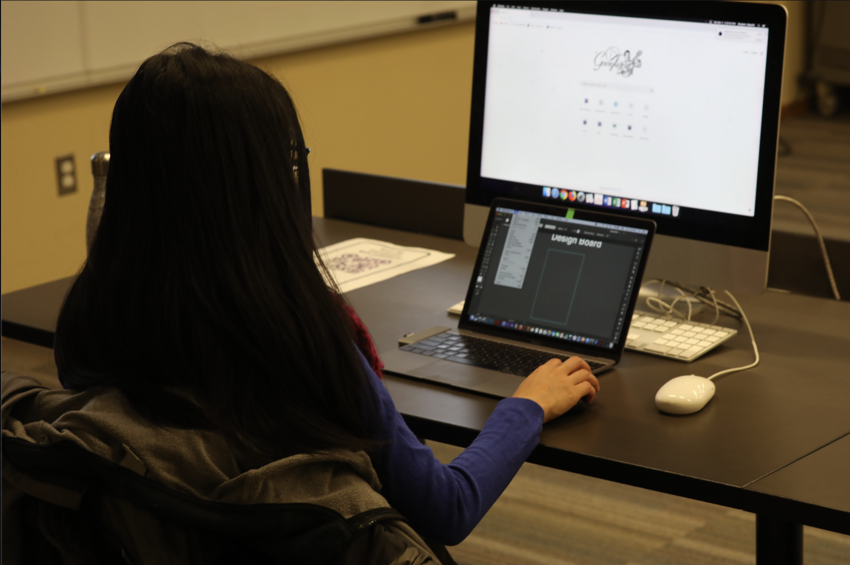

1. **Time management:**

If it’s a one-hour workshop, part of host talking about theoretical concepts should probably be shorter, but it’s not necessary that all remaining time should be part of design exercise. Ask for questions before entering exercise session; if participants is showing passion in discussion of it, cut some time from exercise part and talk more about ReTypography. So there should be a buffer for about 20 minutes that’s able to be allocated into first or second part of the workshop.

1. **Materials:**

Prepare extra pen and paper for participants with no preparation of required laptop or software installed.

1. **Exercise:**

Focus more on the principle of designing grid system, including assessment and workflow, instead of details of creating grid system.